.l1.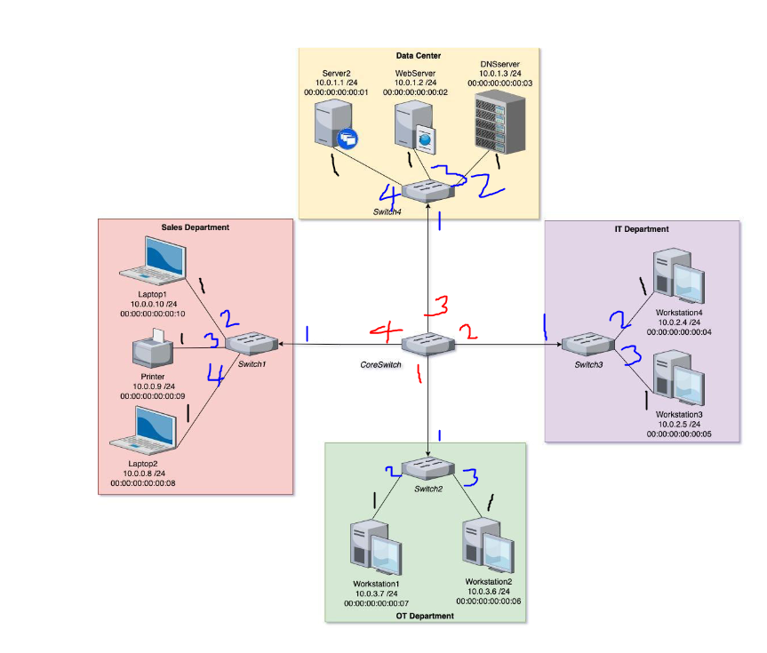

2. You will need to specify specific ports for all traffic (i.e., you cannot use flooding: of.OFPP_FLOOD) and the forwarding must be done by subnet, (not by enumerating

all of the IP addresses).

3. The results are what I expected. All the hosts within the same subnets are able to communicate with each other. And traffic is able to be forwarded to other subnets except for the data center subnet. So hosts in the Data Center should be able to communicate with 2 other hosts within the same subnet. All the other hosts should be able to communicate with all other hosts except for the 3 hosts inside the Data Center.

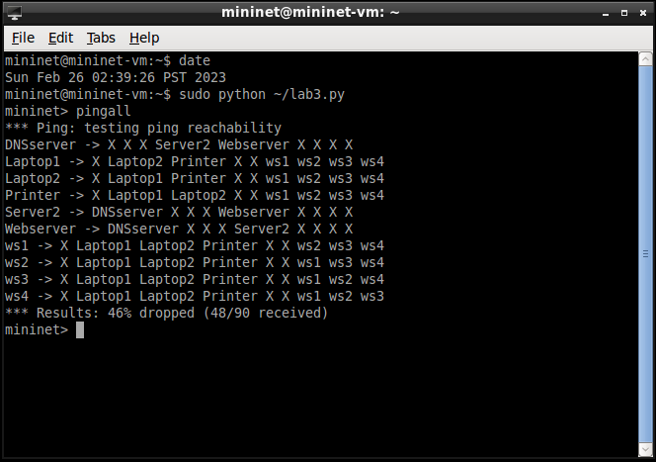

4. Yes the results are what I expected. All the hosts within the same subnets are able to communicate with each other. And traffic is able to be forwarded to other subnets except for the Sales Department subnet.

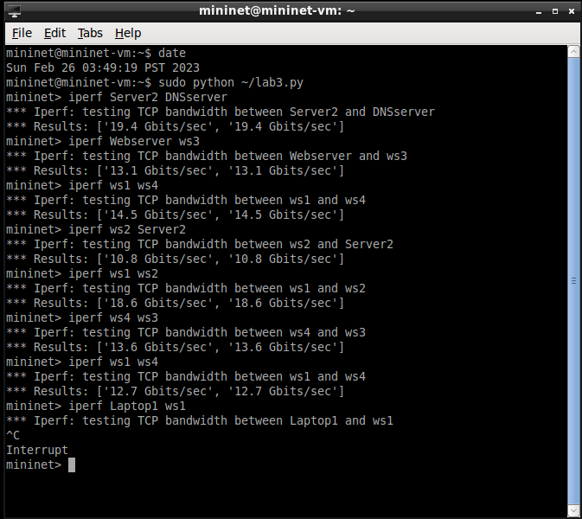

5. The results are what I expected. Hosts are able to communicate through UDP within subnets and to other subnets that are not IT and OT departments, and hosts inside IT and OT departments can still communicate through UDP with each other respectively.

